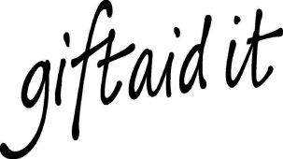
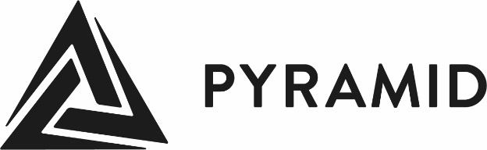

Gift Aid Declaration

Please treat as Gift Aid donations all qualifying gifts of money made

today |  | in the past four years |  | in the future

(Please tick all boxes you wish to apply.)

I am a UK taxpayer and understand that if I pay less Income Tax and or Capital Gains Tax than the amount of Gift Aid claimed on all my donations in that tax year it is my responsibility to pay any difference.

Full name:
Full home address:
Date: |  |  |  | Signature:

You must notify Pyramid of Arts if you

- Want to cancel this declaration
- Change your name or home address
- No longer pay sufficient tax on your income and/or capital gains

If you pay Income Tax at the higher or additional rate and want to receive the additional tax relief due to you, you must include all your Gift Aid donations on your Self-Assessment tax return or ask HM Revenue and Customs to adjust your tax code.

Pyramid of Arts Unit 62 Barkston House, Croydon Street, Leeds LS11 9RT
Registered Charity Number: 1094134 // Company Limited by Guarantee Number: 4498181

